API Gateway using Spring Cloud Gateway

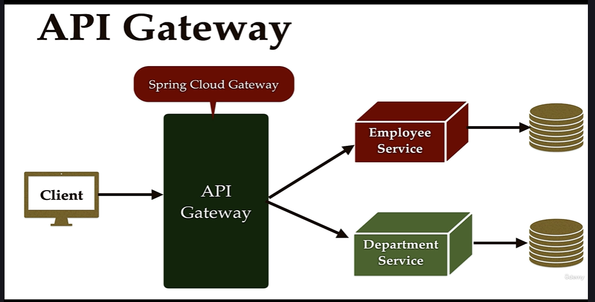

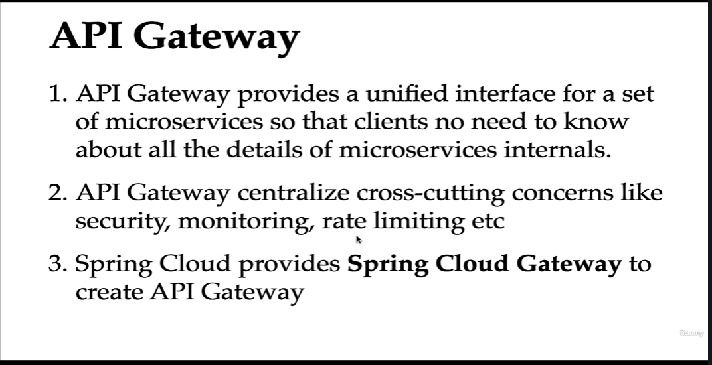

**Update on Using Spring Boot 3 Version**

In the next lecture, make the below change to support Spring Boot 3 and Spring Cloud 2022.0.0:

- Don’t annotate an entry-point **ApiGatewayApplication** class with **@EnableEurekaClient** - This annotation was removed in spring cloud 2022.0.0 and provided auto-configuration.

GitHub repository for Spring Boot 3 - <https://github.com/RameshMF/springboot-microservices/tree/main/v3/springboot-microservices>

========================================================================================================

GET : <http://localhost:9191/api/employees/3>

{

"employee": {

"id": 3,

"firstName": "John",

"lastName": "Paul",

"email": "john.paul@gmail.com",

"departmentCode": "ENG003"

},

"department": {

"id": 4,

"departmentName": "Engineering",

"departmentDescription": "Develops products & maintains systems",

"departmentCode": "ENG003"

}

}

========================================================

GET: <http://localhost:9191/api/departments/ENG003>

{

"id": 4,

"departmentName": "Engineering",

"departmentDescription": "Develops products & maintains systems",

"departmentCode": "ENG003"

}

==========================================================================================================